**Nguyễn Văn Đảng câu 1-13**

**Phạm Anh Hào 14-26**

**Trần Phước Anh Vũ 27-39**

**Đinh Ngọc Hoàng Nam 40-52**

**Link github**

[**https://github.com/TeddyBear05/LAB3**](https://github.com/TeddyBear05/LAB3)

39.

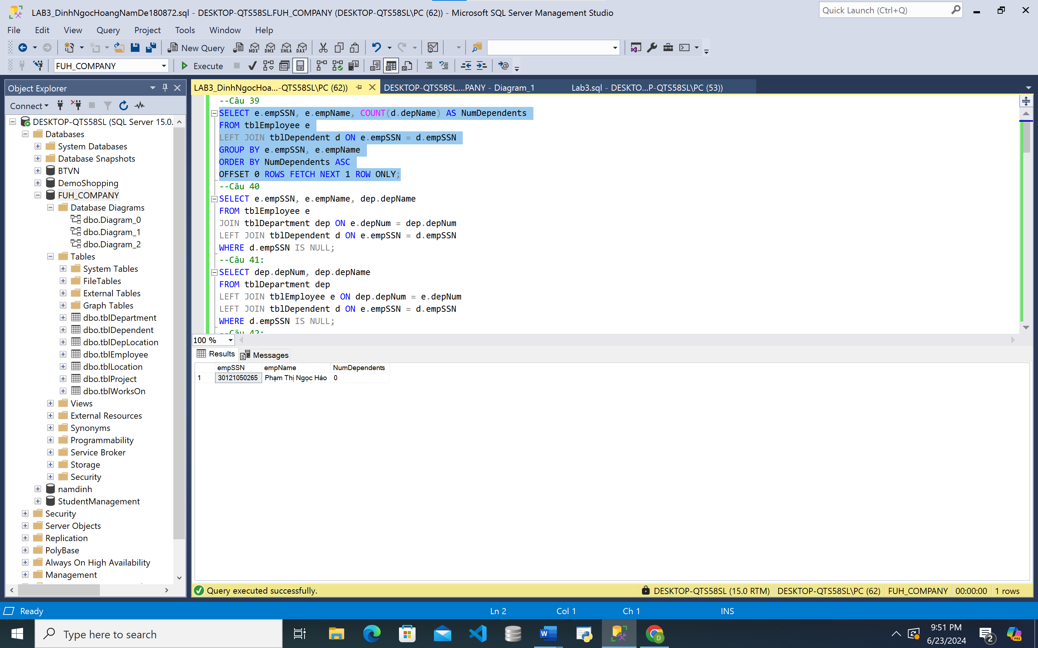

**40.**

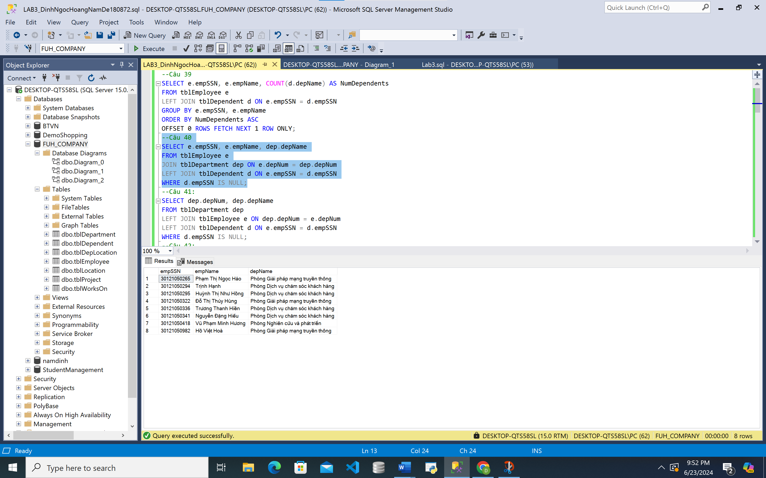

**41.**

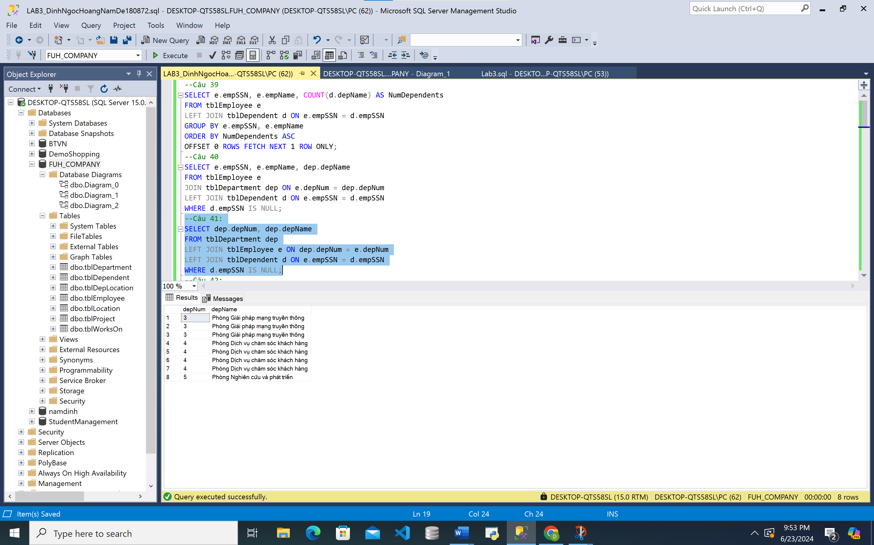

**42.**

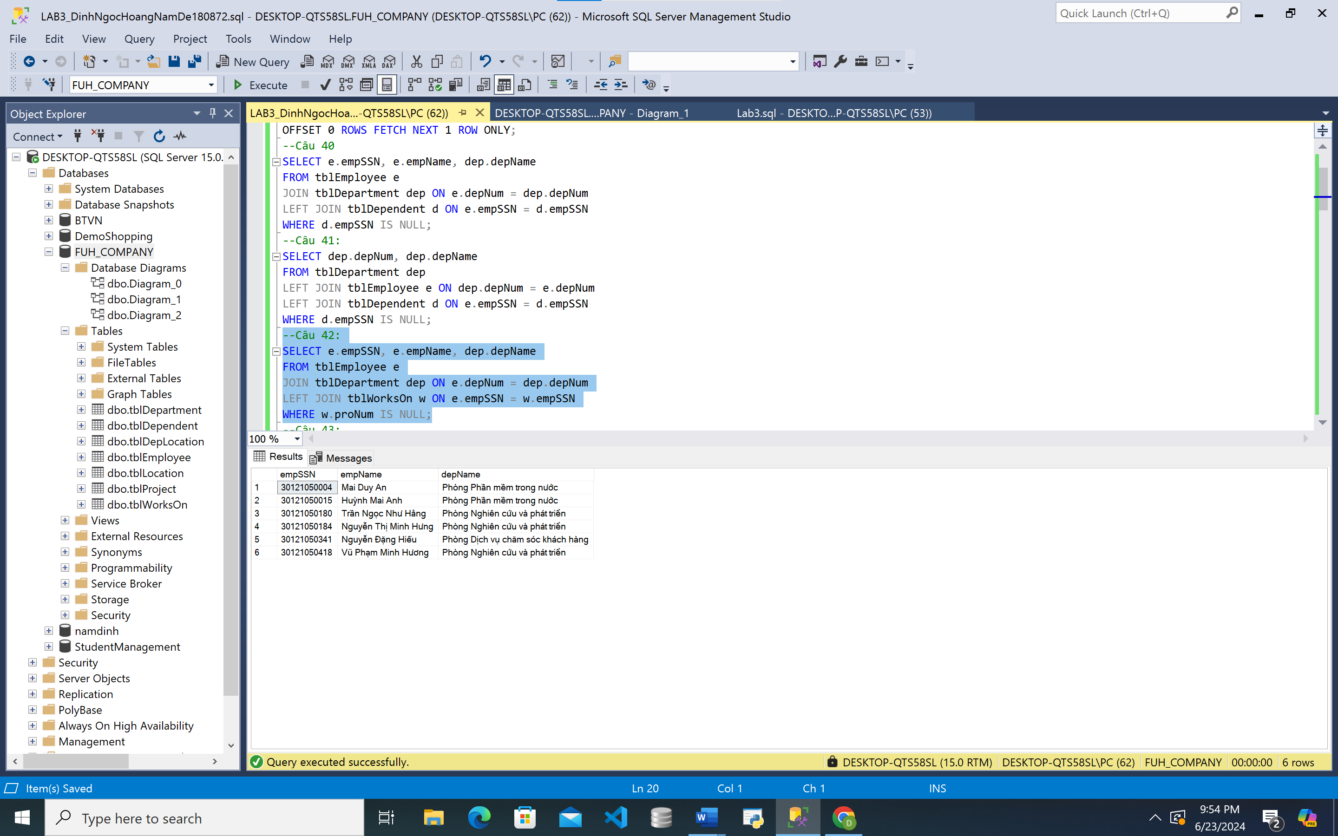

**43.**

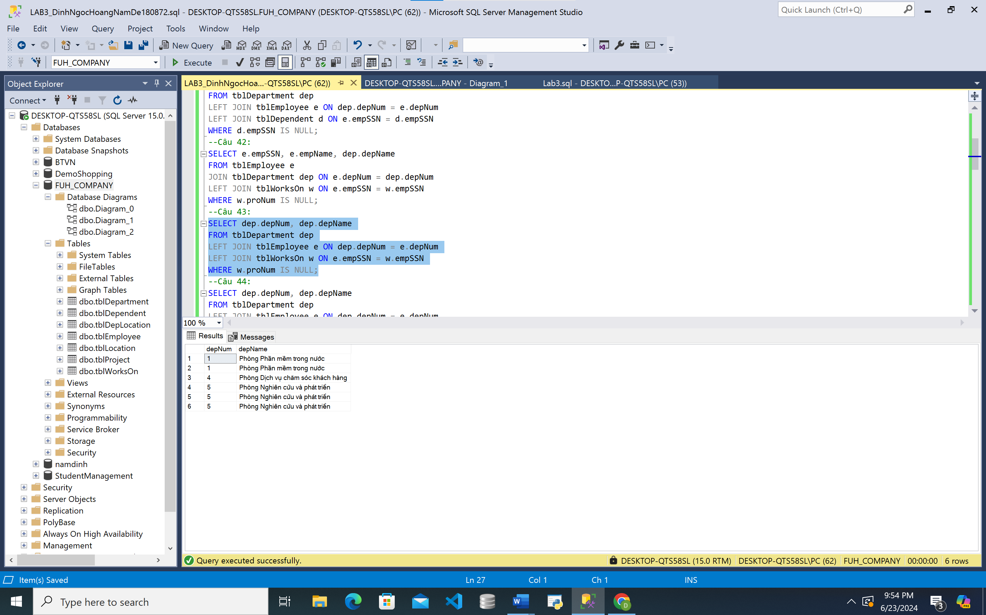

**44.**

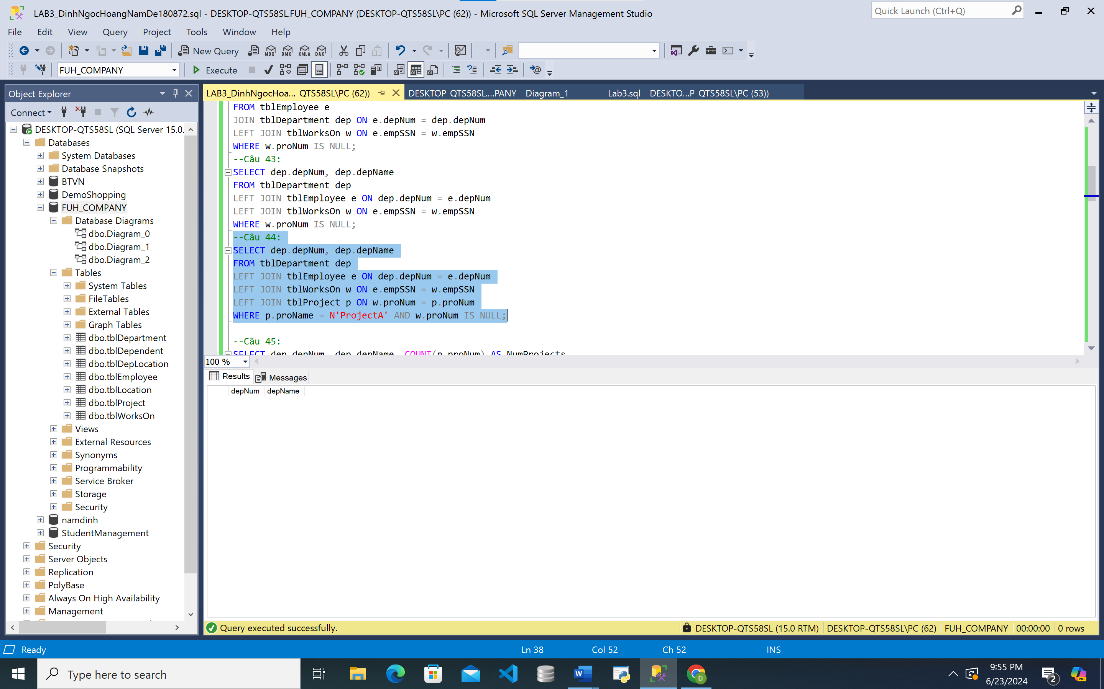

**45.**

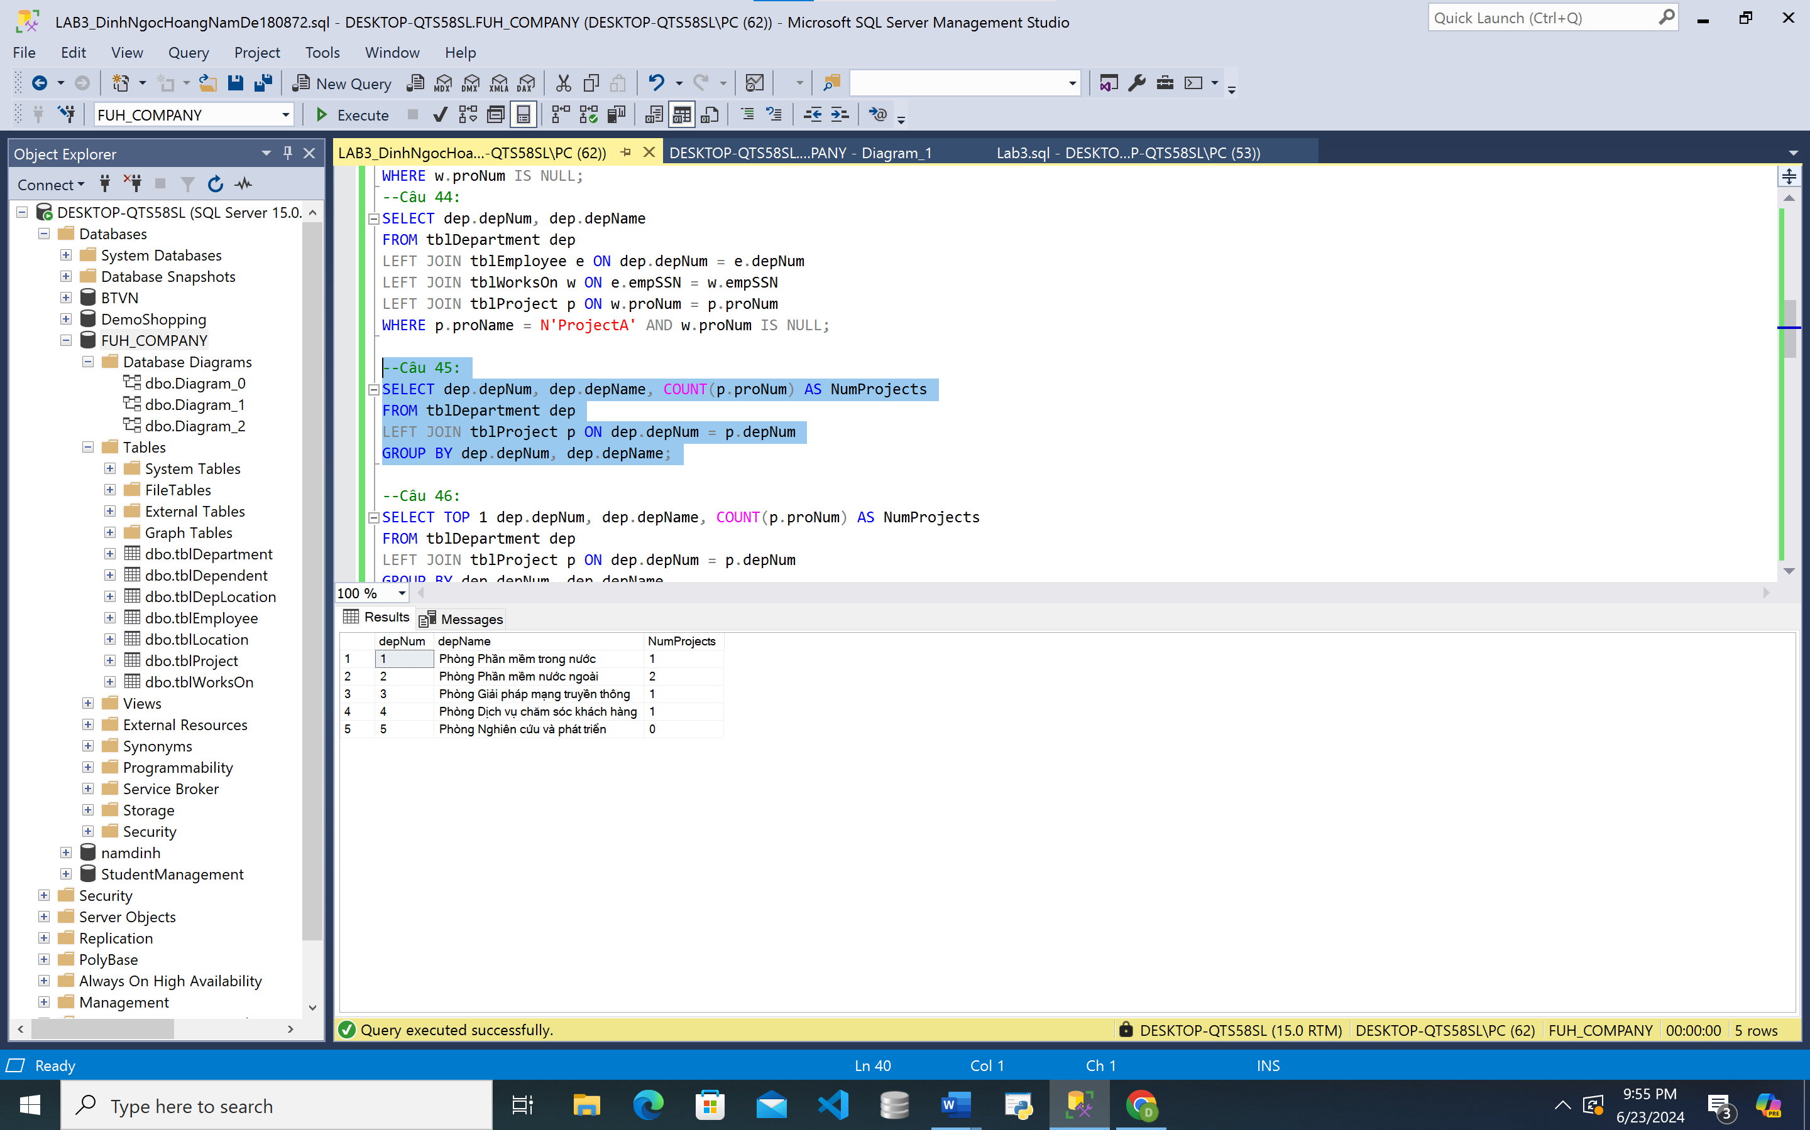

**46.**

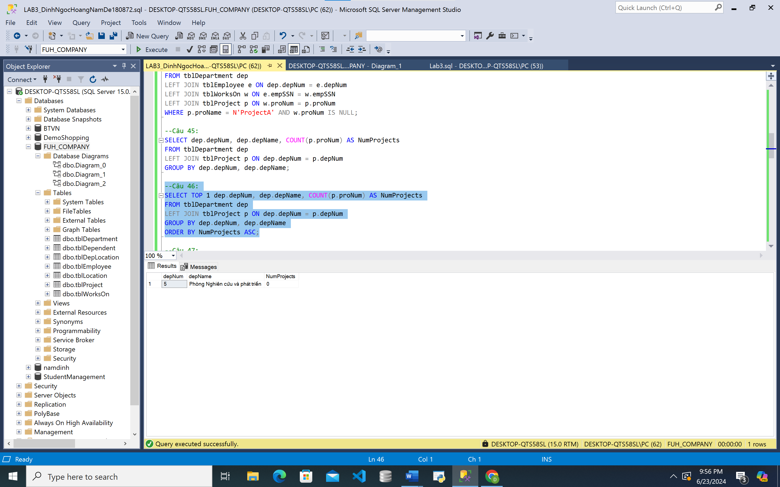

**47.**

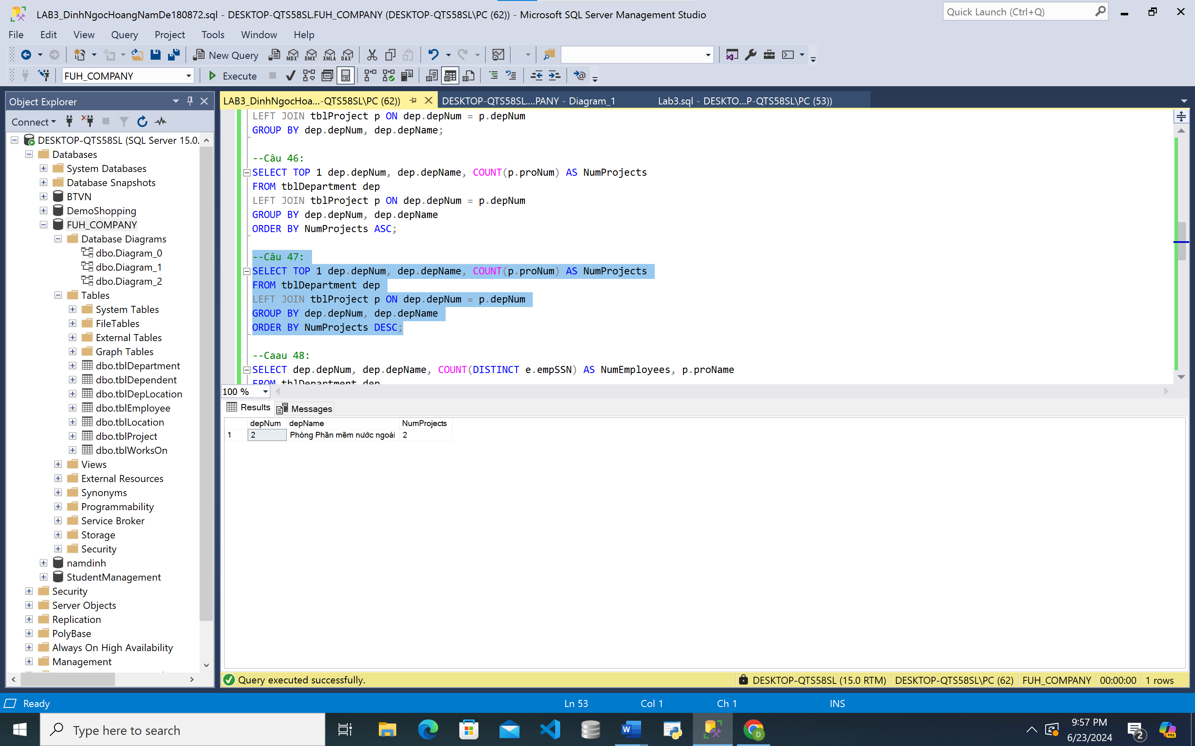

**48.**

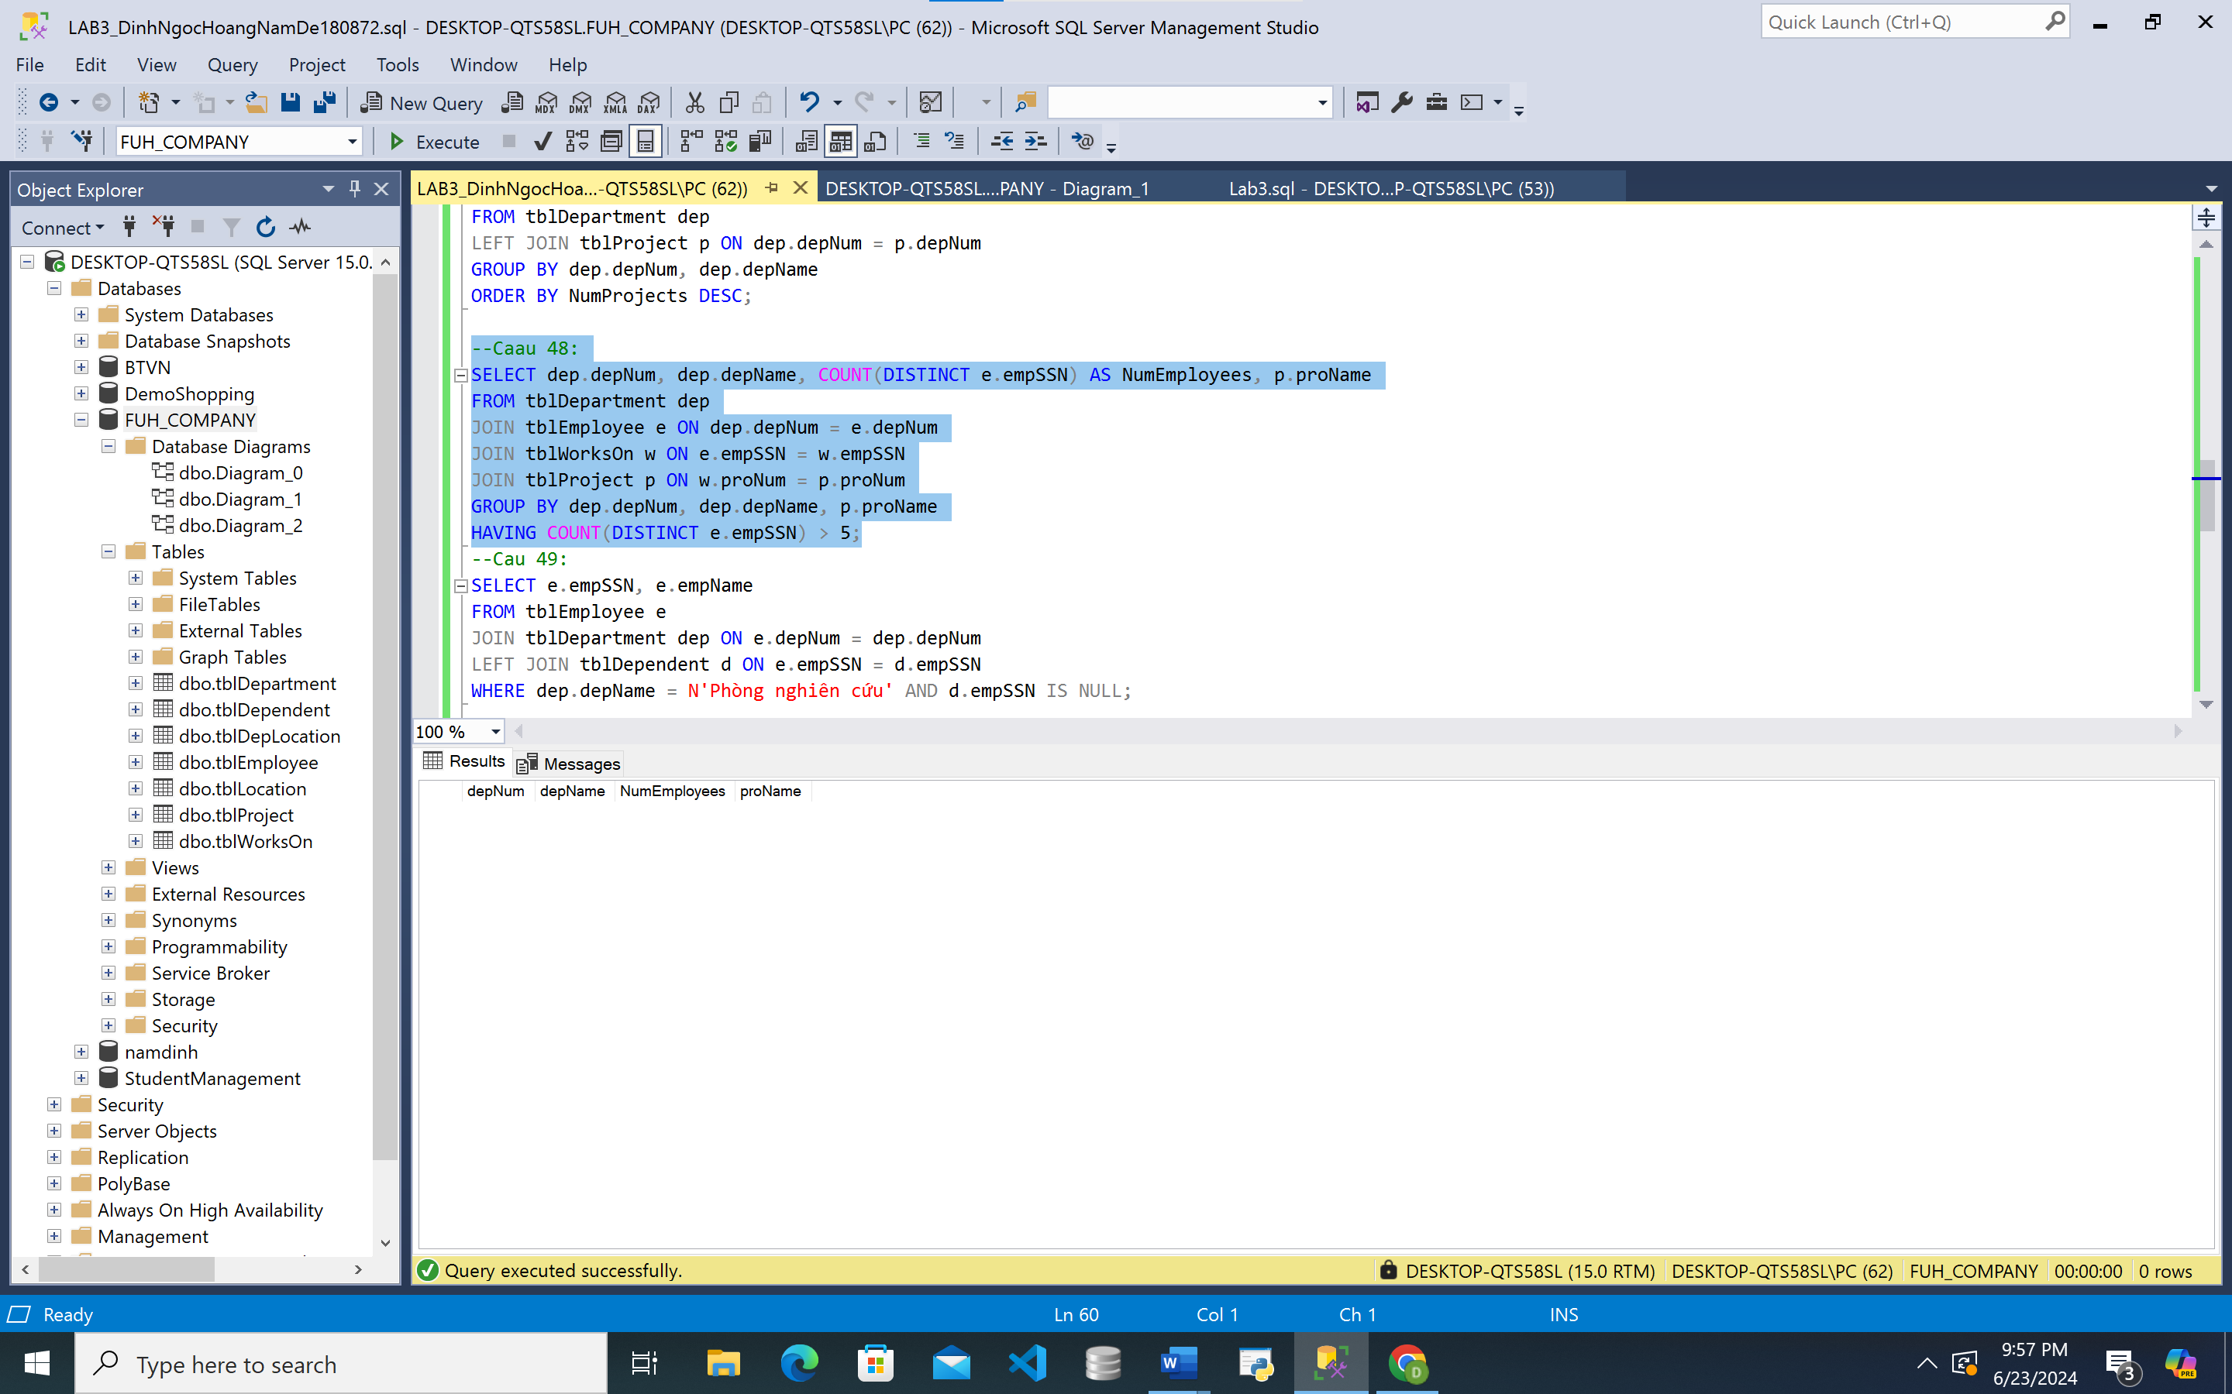

**49.**

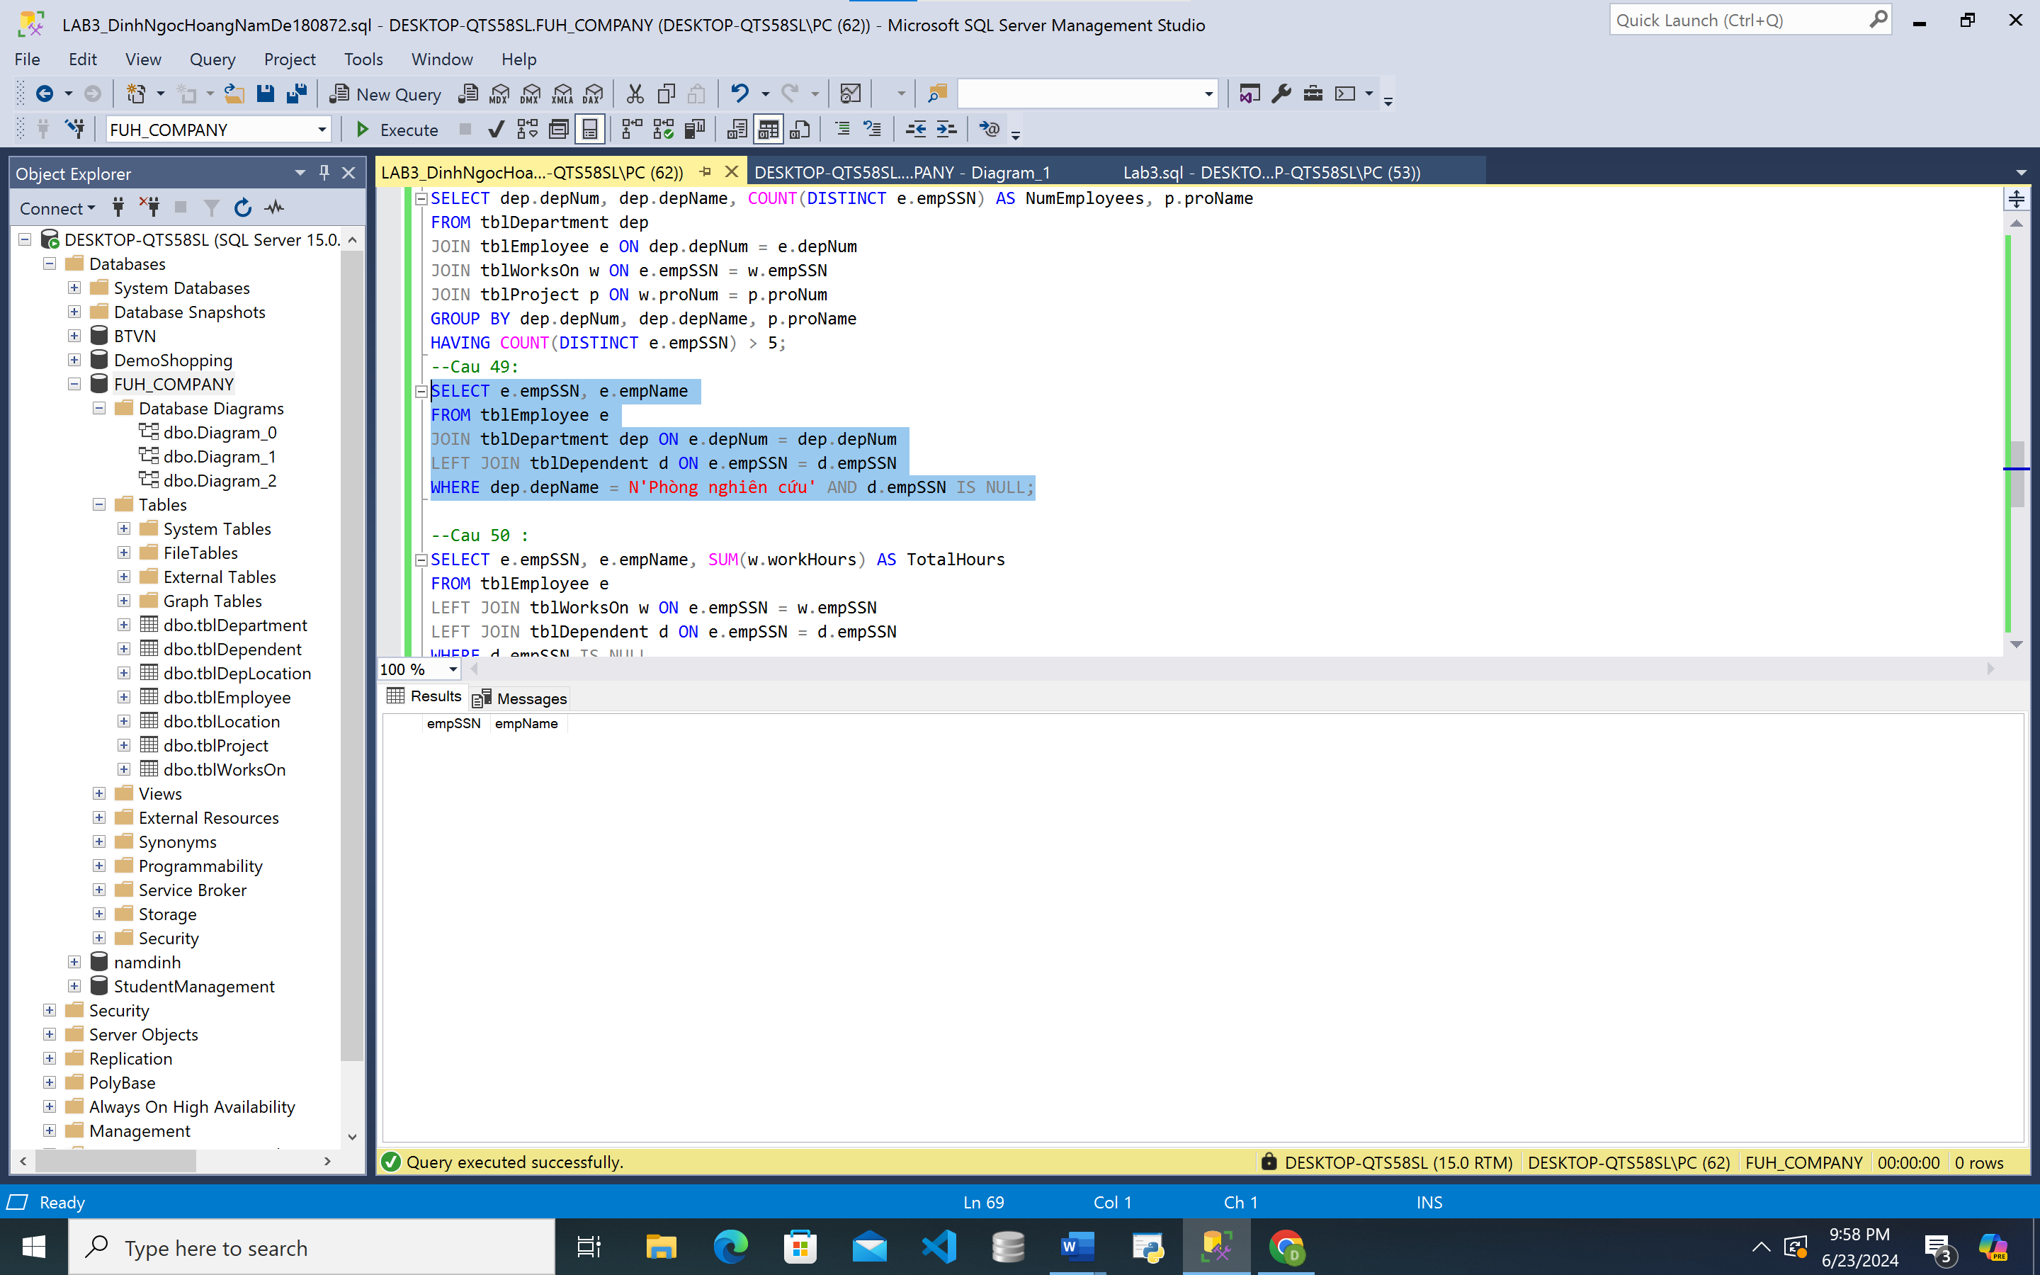

**50.**

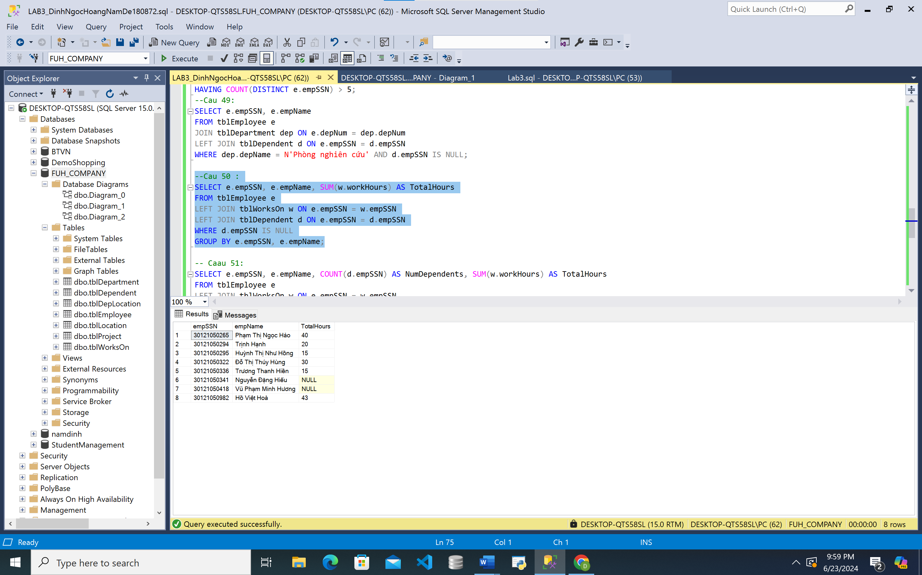

**51.**

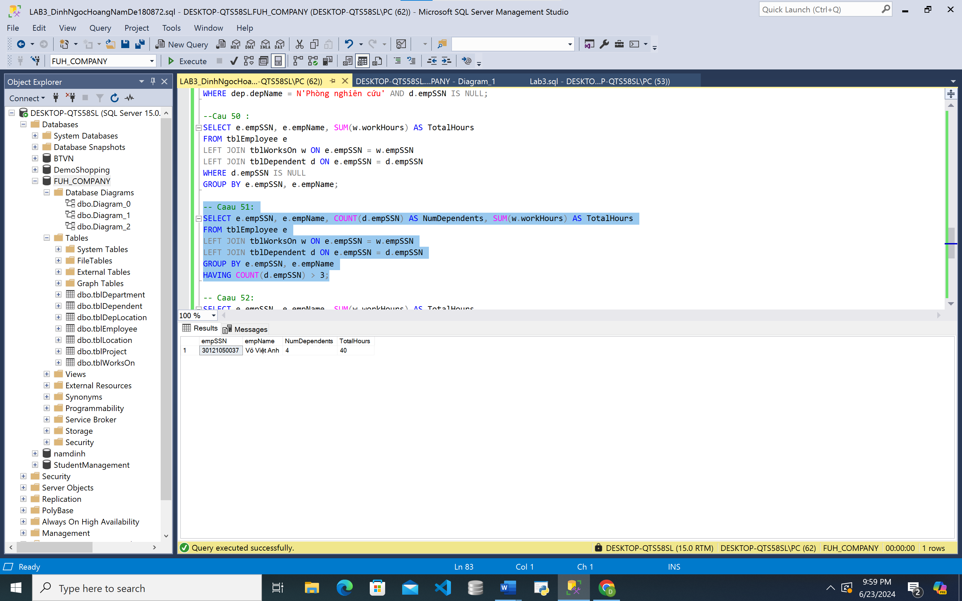

**52.**

